ANTIKA DAS (07/10/2020)

CONVOLUTIONAL NEURAL NETWORK FEATURE MAP VISUALIZATION

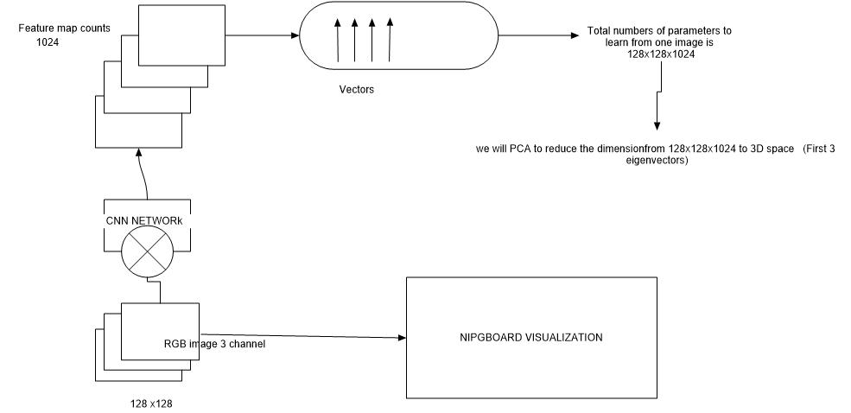

Plan:

We will have RGB images which usually has 3 channels, this RGB image will be the input of CNN network, and we want to know/visualize how our network learn the features of the image. We will take 1024 filters on the 128x128 image which will create 1024 features maps which will be stack on each other and create vector of (128x128x1024)\*, now we want to reduce/localize this dimension to 3D space using PCA. For this dimension reduction we will take first 3 component/eigenvectors. [we can have 10000 RGB images for examples and we want to learn feature map for all of them 128x128x10000]

Original Images will go to nipgboard for human visualization and understanding.

\*Confusion: - Inside a CNN there can be multiple conv layers and each conv layer will have their own feature maps, after each conv layer the dimension of the original input images will keep reducing, so exactly which feature maps we want to visualize-- from all the conv layers or only first or last layer? Do we need to use padding in order to avoid reducing the original input size?